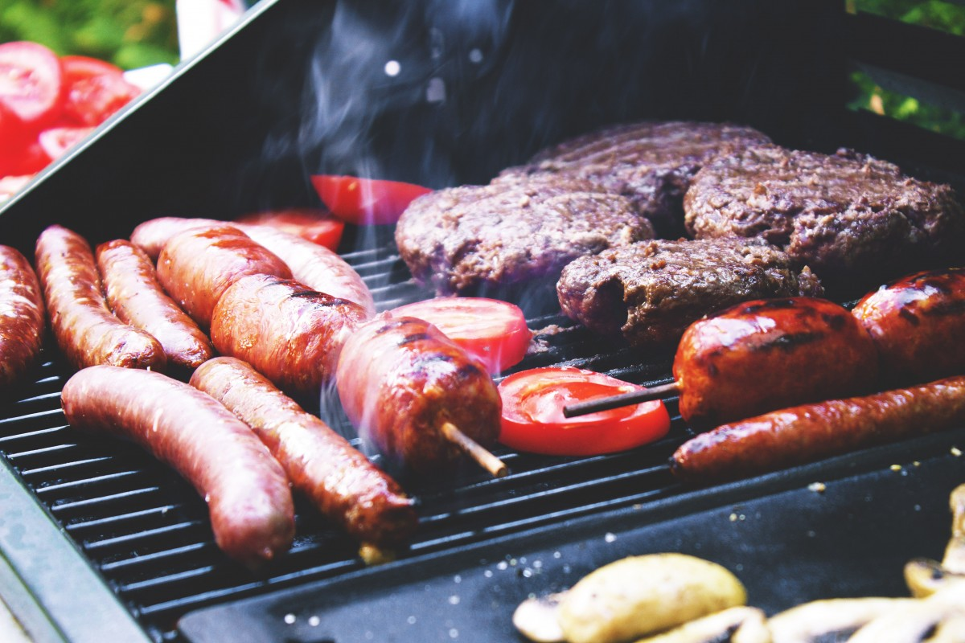

Legion Back Yard Grill Sunday’s From 12 to 5pm

- Hot Dogs (1/4 lb) $3.50
- Hamburger $4.50
- Bratwurst $3.50
- Italian Sausage – Hot or Mild $3.50
- Chicken Sandwich Grilled
* Classic – Mayonnaise, Pickle $5.00
* Deluxe – Mayonnaise, Lettuce Tomato, Pickles $5.50
* ( Spicy upon Request )

TOPPINGS
- Cheese $0.50
- Onions $0.50
- Peppers $0.50
- Sauerkraut $0.50

